Using Functions

Function: Collection of Statements, with name defined

Program :: Calling function f1(), 5 times

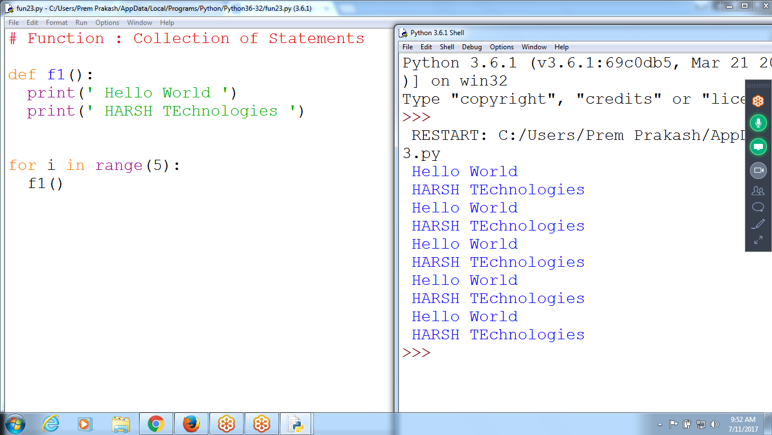

Passing Parameters to a Function

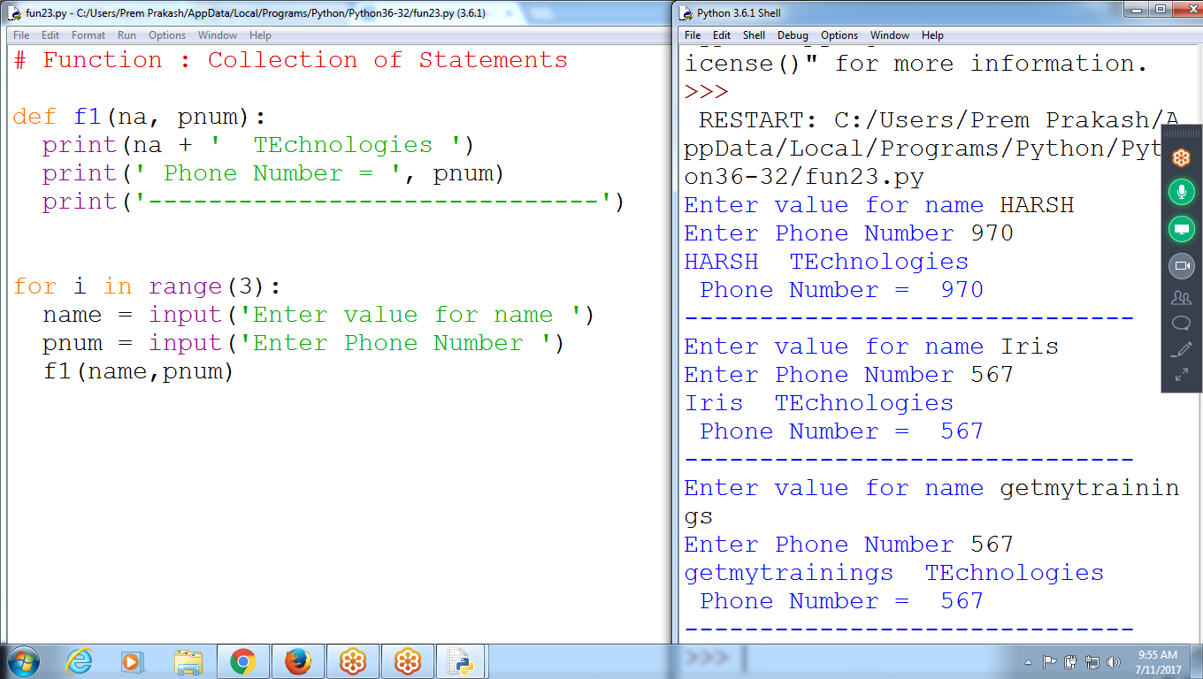

# Function : Collection of Statements

def f1(na, pnum):

print(na + ' TEchnologies ')

print(' Phone Number = ', pnum)

print('------------------------------')

for i in range(3):

name = input('Enter value for name ')

pnum = input('Enter Phone Number ')

f1(name,pnum)

Without Return Statement find Net Salary

Accepting Eid, ename and basic salary

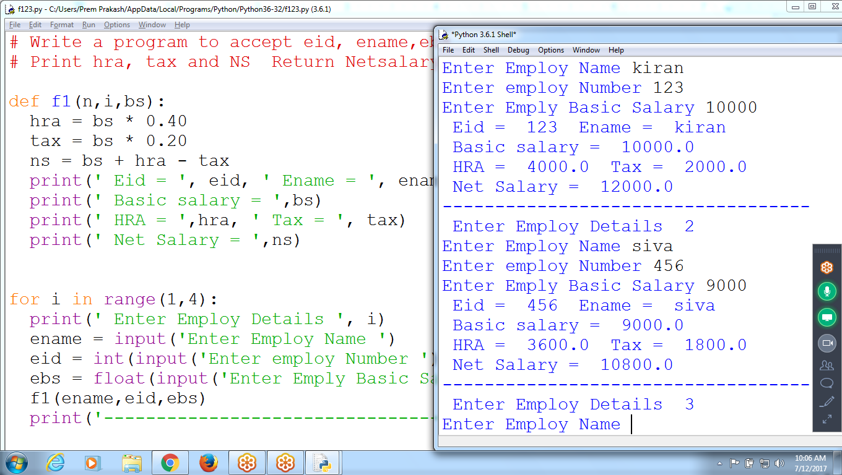

3) How a function returns values

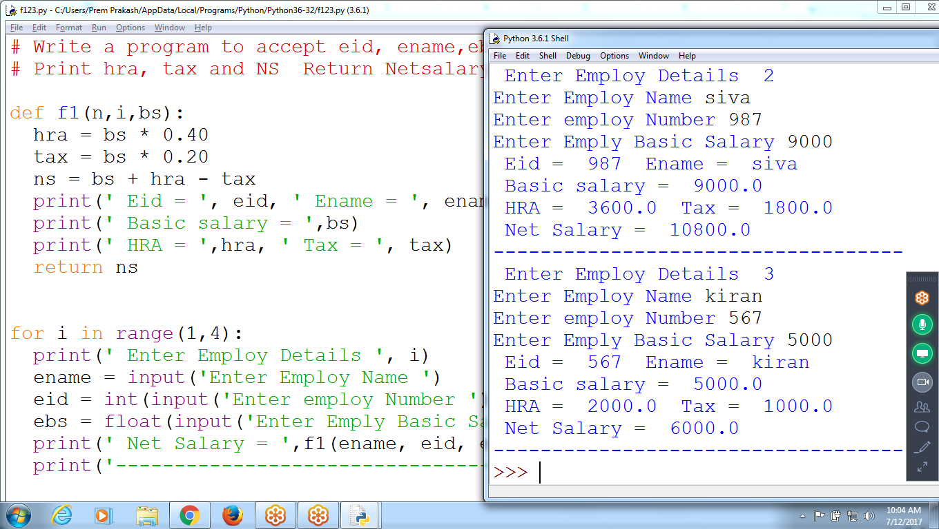

# Write a program to accept eid, ename,ebs

# Print hra, tax and NS Return Netsalary

def f1(n,i,bs):

hra = bs * 0.40

tax = bs * 0.20

ns = bs + hra - tax

print(' Eid = ', eid, ' Ename = ', ename)

print(' Basic salary = ',bs)

print(' HRA = ',hra, ' Tax = ', tax)

return ns

for i in range(1,4):

print(' Enter Employ Details ', i)

ename = input('Enter Employ Name ')

eid = int(input('Enter employ Number '))

ebs = float(input('Enter Emply Basic Salary ' ))

print(' Net Salary = ',f1(ename, eid, ebs))

print('-----------------------------------')

Default Parameters

If a value is provided, it will overwrite the default value.

Any number of arguments in a function can have a default value. But once we have a default argument, **all the arguments to its right must also have default values.**

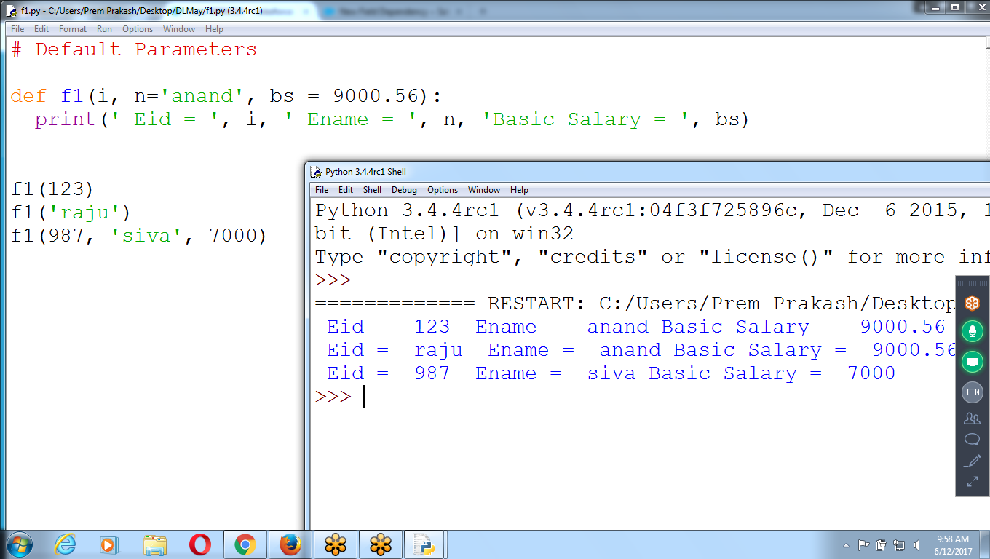

# Default Parameters

def f1(i, n='anand', bs = 9000.56):

print(' Eid = ', i, ' Ename = ', n, 'Basic Salary = ', bs)

f1(123)

f1('raju')

f1(987, 'siva', 7000)

n**on-default arguments cannot follow default arguments**.

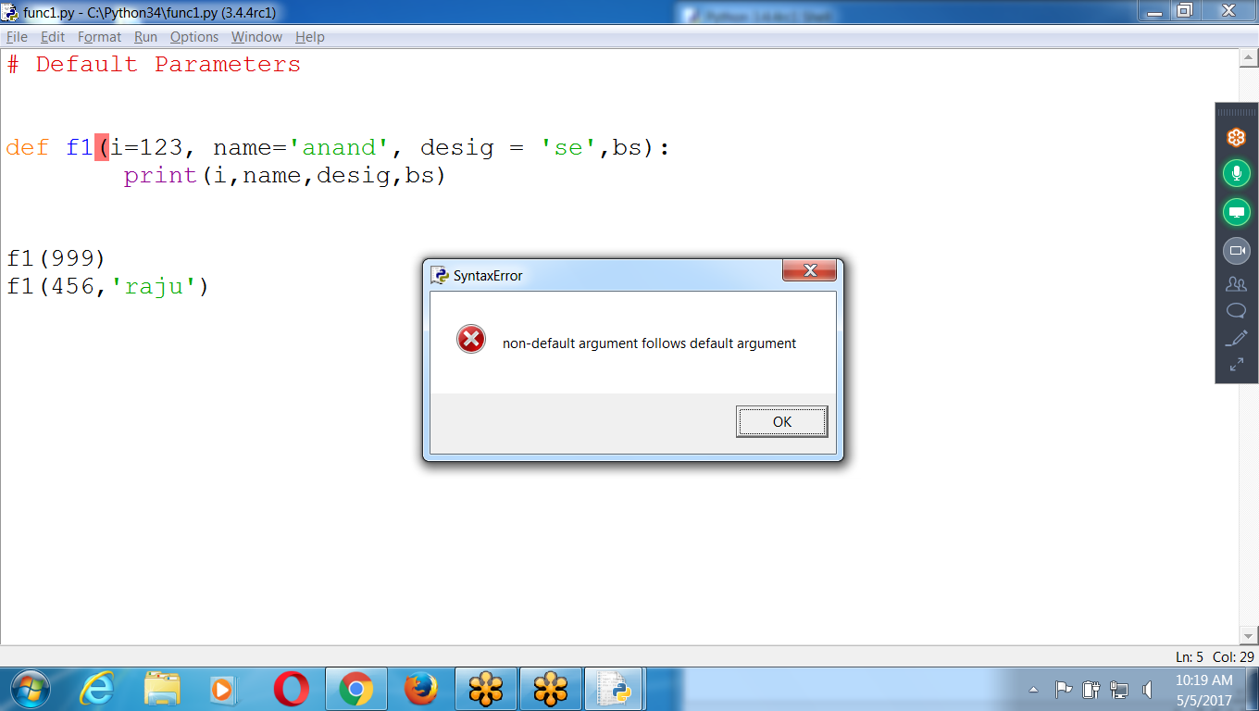

### **Python Keyword Arguments**

Call a function with some values, these values get assigned to the arguments according to their position.

can mix positional arguments with keyword arguments during a function call. But we must keep in mind that keyword arguments must follow positional arguments.

Function can receive with single parameter

Multiple Parameters Function

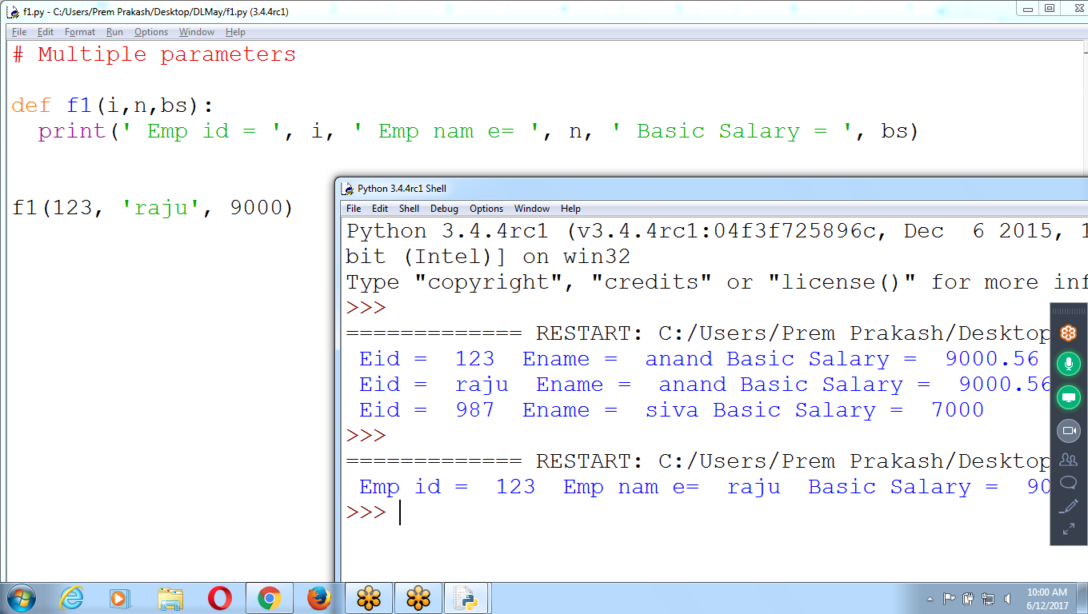

# Multiple parameters

def f1(i,n,bs):

print(' Emp id = ', i, ' Emp nam e= ', n, ' Basic Salary = ', bs)

f1(123, 'raju', 9000)

Passing multiple parameters, receiving single par :: Error

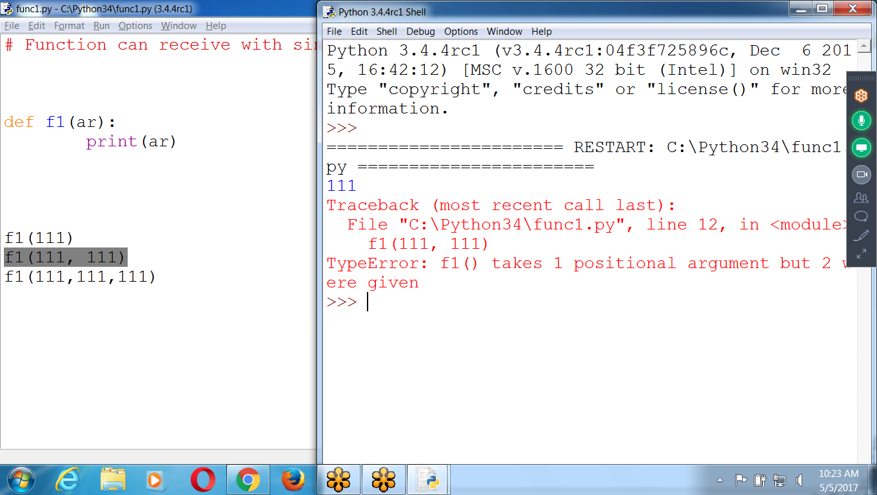

Multiple parameters and receive single para using *parameter

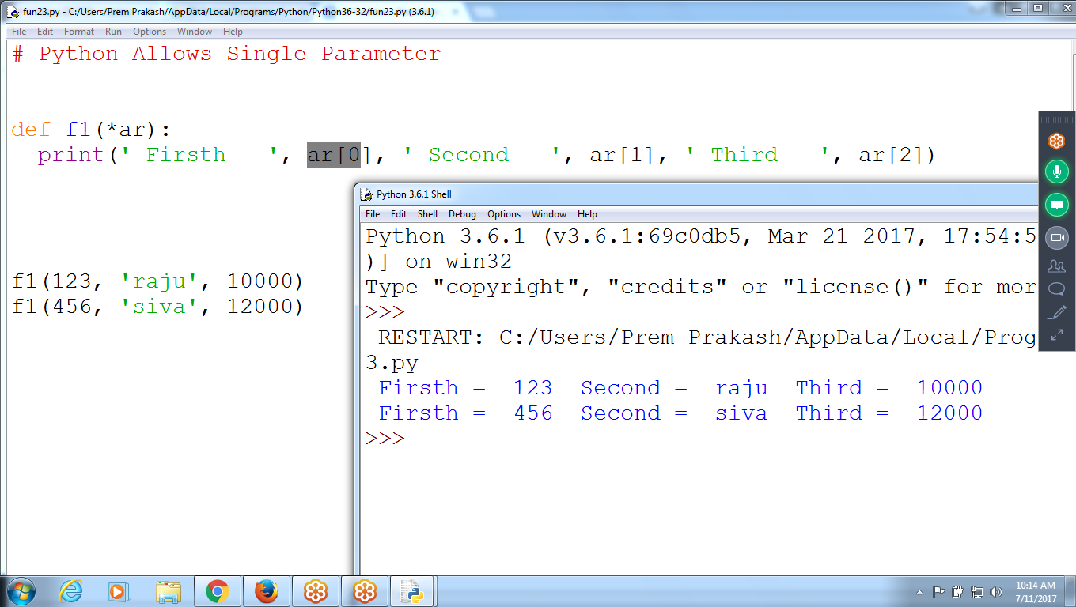

# Multiple parameters

def f1(*ar):

print(' Firsth = ', ar[0], ' Second = ', ar[1], ' Third = ', ar[2])

f1(123, 'raju', 10000)

f1(456, 'siva', 12000)

Receiving Multiple Parameter values

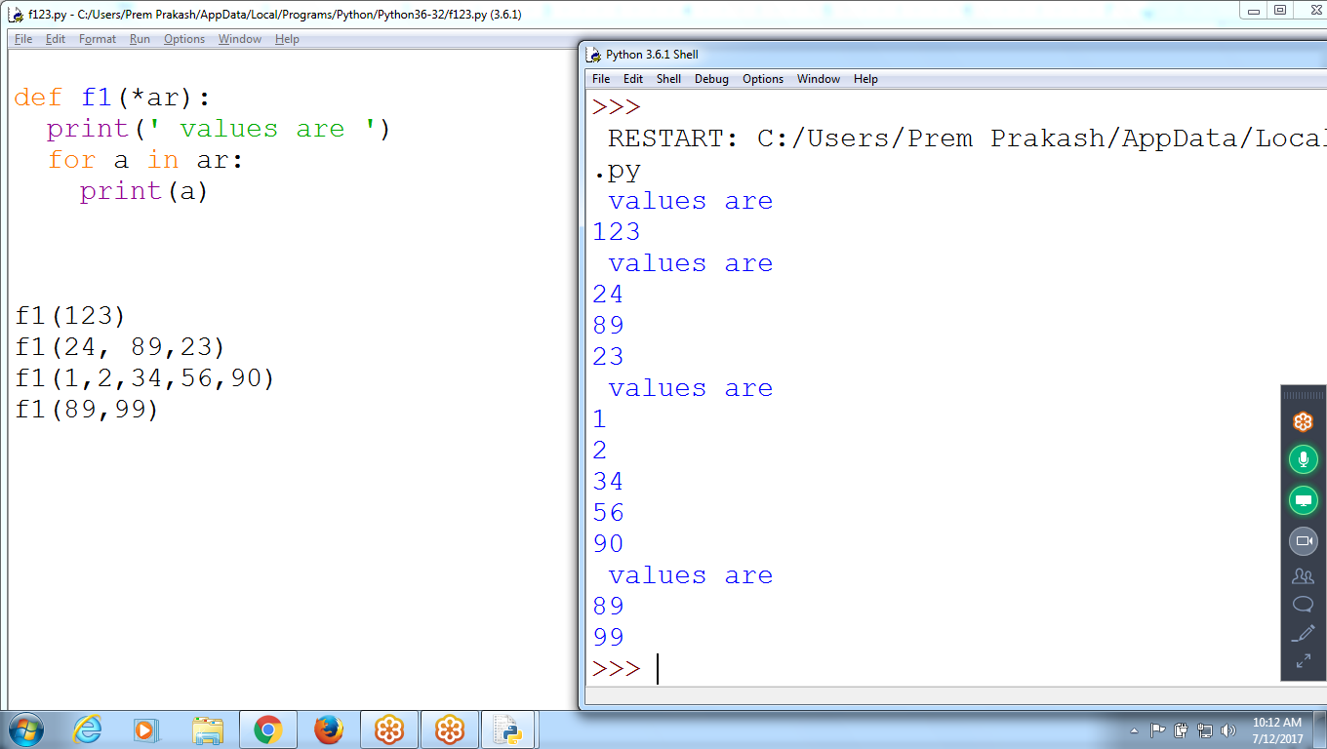

def f1(*ar):

print(' values are ')

for a in ar:

print(a)

f1(123)

f1(24, 89,23)

f1(1,2,34,56,90)

f1(89,99)

Multiple Function Names and Multiple Parameters

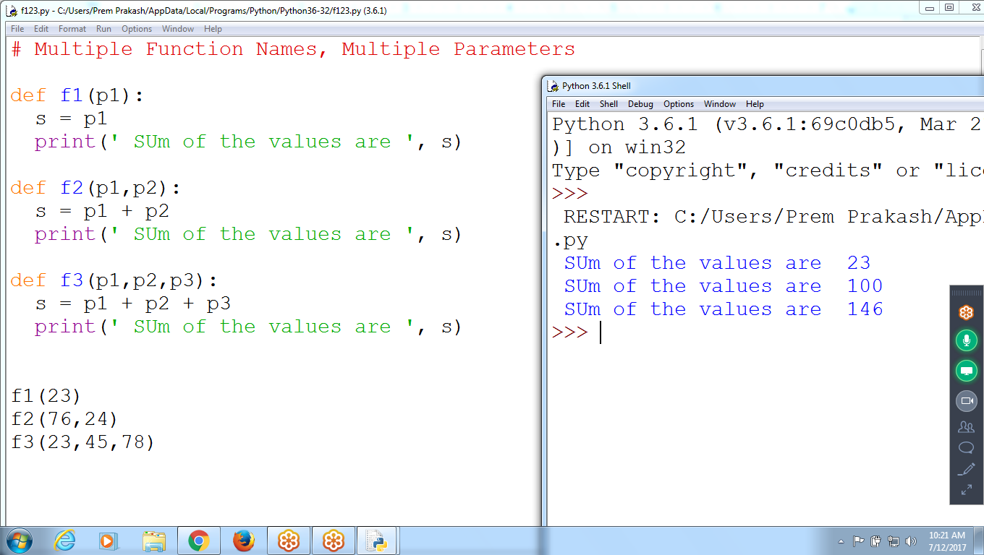

# Multiple Function Names, Multiple Parameters

def f1(p1):

s = p1

print(' SUm of the values are ', s)

def f2(p1,p2):

s = p1 + p2

print(' SUm of the values are ', s)

def f3(p1,p2,p3):

s = p1 + p2 + p3

print(' SUm of the values are ', s)

f1(23)

f2(76,24)

f3(23,45,78)

# Find Sum of the values with Single parameter

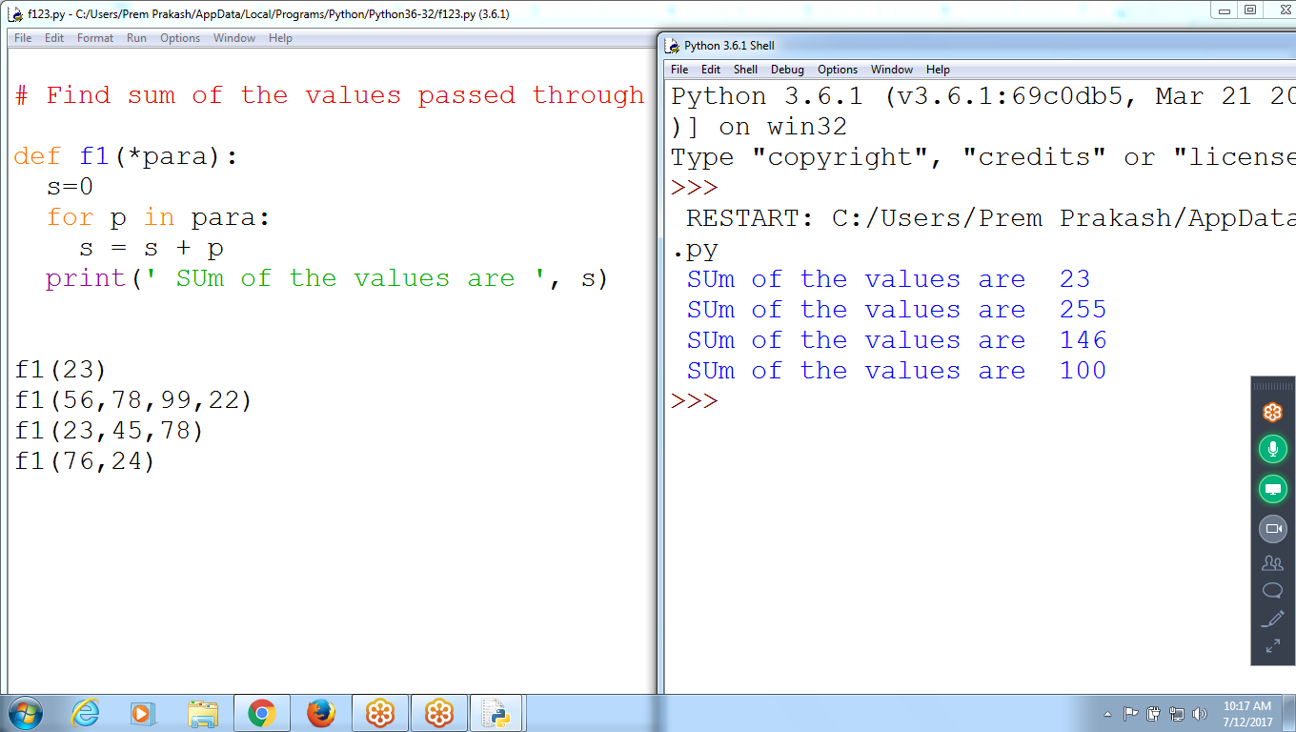

# Find sum of the values passed through function

def f1(*para):

s=0

for p in para:

s = s + p

print(' SUm of the values are ', s)

f1(23)

f1(56,78,99,22)

f1(23,45,78)

f1(76,24)

>>> a =10

>>> b = 24

>>> a+b

34

>>>

>>> st = 'ramu'

>>> st +a # String + integer

Traceback (most recent call last):

File "<pyshell#5>", line 1, in <module>

st +a

TypeError: must be str, not int

>>>

Error Message:::

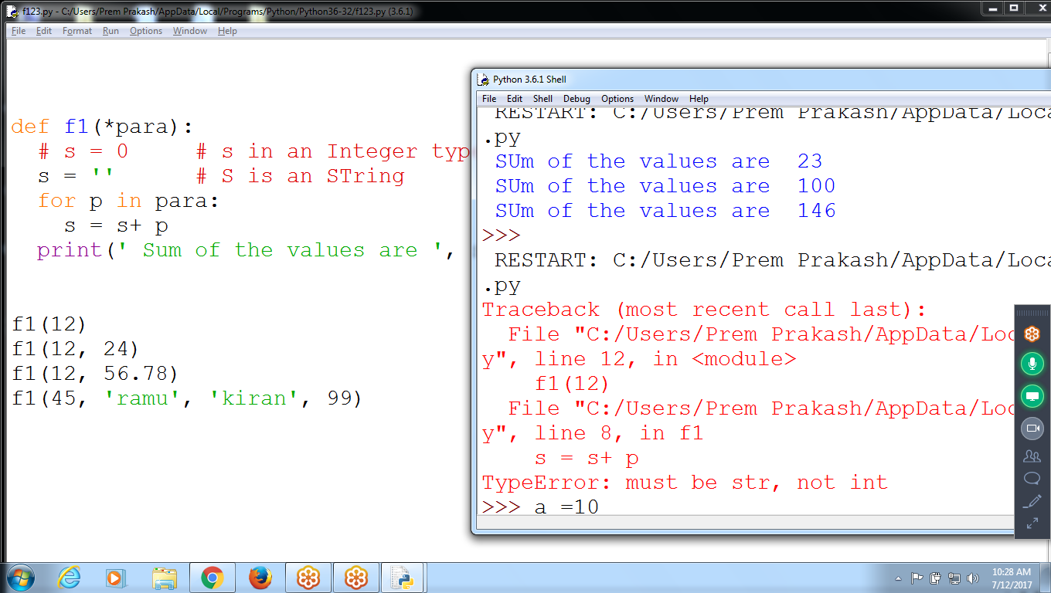

def f1(*para):

# s = 0 # s in an Integer type

s = '' # S is an STring

for p in para:

s = s+ p

print(' Sum of the values are ', s)

f1(12)

f1(12, 24)

f1(12, 56.78)

f1(45, 'ramu', 'kiran', 99)

Find Factorial of Given Number until user press ‘0’

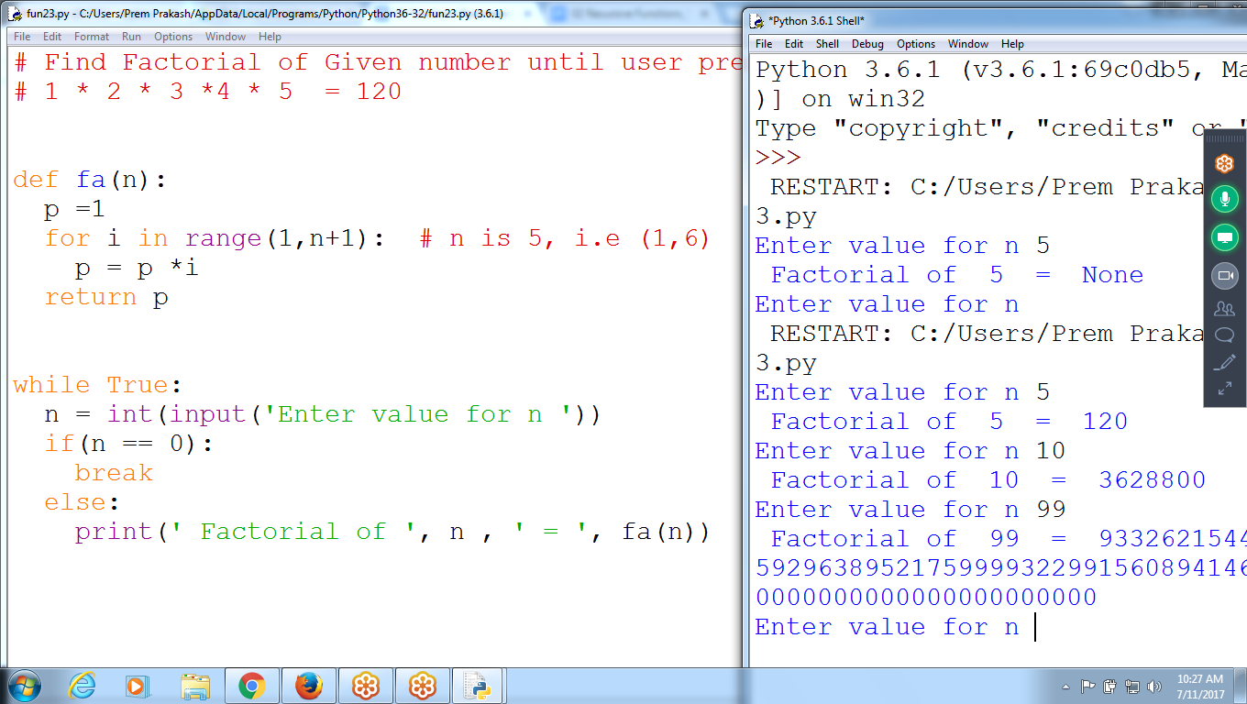

# Find Factorial of Given number until user press '0'

# 1 * 2 * 3 *4 * 5 = 120

def fa(n):

p =1

for i in range(1,n+1): # n is 5, i.e (1,6)

p = p *i

return p

while True:

n = int(input('Enter value for n '))

if(n == 0):

break

else:

print(' Factorial of ', n , ' = ', fa(n))

